**Project requirements**

*Team name:* “Comrades”

*Team leader:* Antonio Freire

*Team members:* Daria Hryshkova, Alexander Volynchikov, Helen Boitsova, Antonio Freire, Aysen Armagan

**Part 1:**

HTML and CSS - home page, public & admin interface, header footer, navigation

Must be RESPONSIVE!

**Part 2:**

List of features:

1. Forum – **Tier 3 - Aysen**
2. Registration, login (admin and users) + retrieve password – **Tier 2 - Antonio**
3. Search – **Tier 1 - Antonio**
4. View, edit, delete and add pages (CMS) – **Tier 3 - Helen**
5. Contact us (+ admin part ) – **Tier 2** - **Alexander**
6. Gallery – **Tier 2 - Aysen**
7. Finance calculator – **Tier 3 - Darya**
8. Donations – **Tier 1** - **Alexander**
9. Newsletter – **Tier 2 - Darya**
10. Find the nearest shop and hospital – **Tier 2 - Helen**
11. User ranking of posts and Comments (+ sorting posts) – **Tier 2 - Helen**
12. Incorporating API’s (Twitter, Facebook, Google, etc.) – **Tier 1 - Darya**
13. [Questionnaire](https://slovari.yandex.ru/questioning/en-ru) – **Tier 2** - **Alexander**
14. User Cabinet – **Tier 2 - Antonio**
15. Promotions pages – **Tier 1 - Aysen**
16. **Forum**

Users could open a topic write entries and answer to question that have been asked.

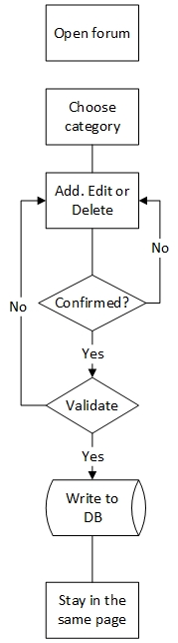

1. **Registration, login (admin and users)** – Tier 1 **+ retrieve password** – Tier 2

Users could create accounts with their email and login to the system with their username and password. To make this more complex we can add Tier 2 – users can retrieve their password.

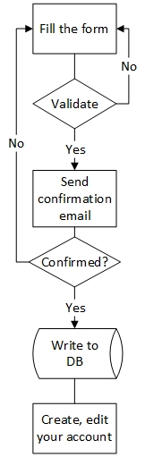

1. **Search** – Tier 1

Users could search something in whole website or in a specific category.

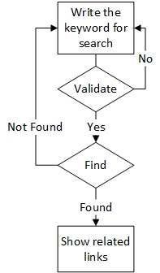

1. **View, edit, delete and add pages (CMS)** – Tier 3

Admins could create new pages, edit current ones or delete the ones that they don’t want to publish anymore. These pages are same with the blog posts. Admins could add pictures, YouTube videos and plain text. By edit, we mean not only edit content but publish and un publish pages too.

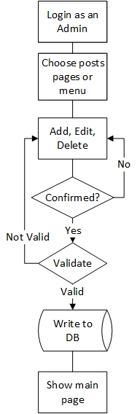

1. **Contact us (+ admin part** ) – Tier 2

Users could create and send emails to admins. Admins can answer to users. All messages are saved in DB.

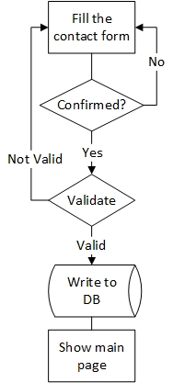

1. **Gallery** – Tier 2

Admins could create, edit, and delete images into/out of galleries.

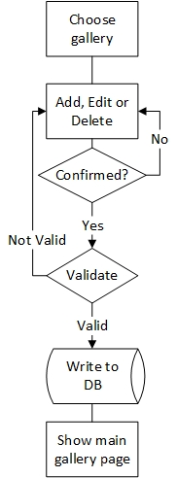

1. **Finance calculator** – Tier 3

Users could enter their income, the amount that they want to save this month and their expenses to calculate the rest amount for this month.

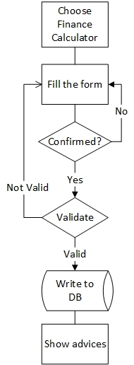

1. **Donations** – Tier 1

Users could donate the developer team with paypal. We can add Tier 2 – add other systems to pay.

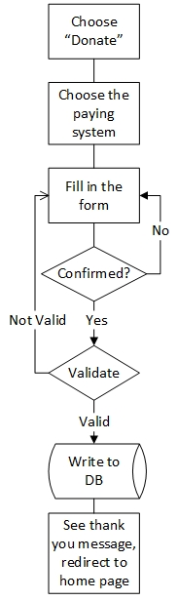

1. **Newsletter** – Tier 2

Users could subscribe for getting email from the website about new posts. Create admin page with creating a distribution ability (Emails are formed by admin). We can add Tier 3 so admin can create Newsletter templates and send emails about subscribing and Thank you emails for donate feature and we can create users groups and sent emails only for proper groups.

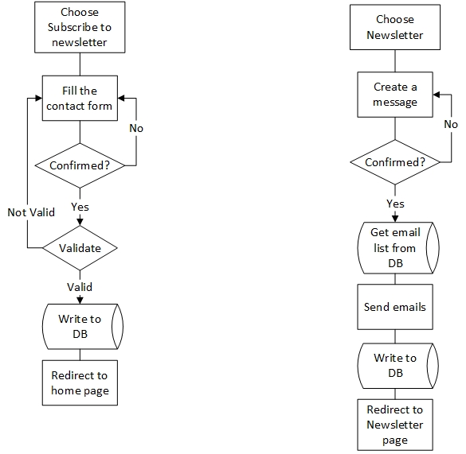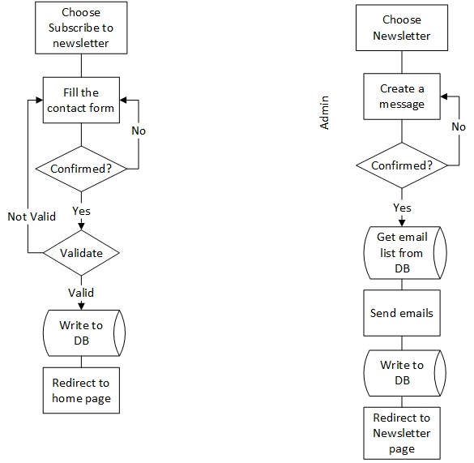

1. **Find the nearest shop and hospital**

With the use of users’ location they could find nearest shop or hospital.

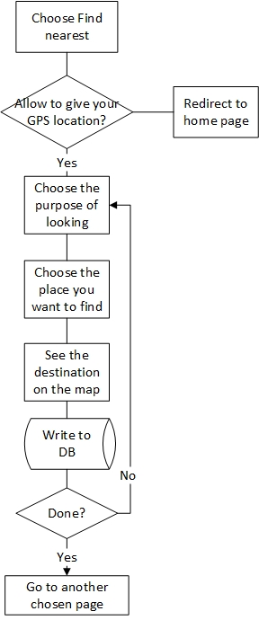

1. **User ranking of posts and Comments (+ sorting posts)** – Tier 2

User could give ranking to the posts. Or write comments. We will put 5 stars and let users give their ranking of posts on our site. We can use this ranking to show sort posts by most recent and most loved and commented.

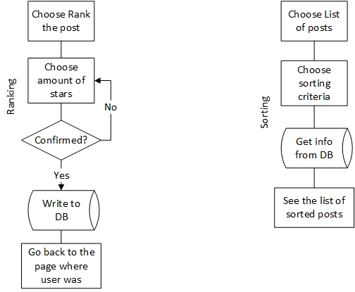

1. **Incorporating API’s (Twitter, Facebook, Google, etc.)**

Users could share the post of website on one these social networks.

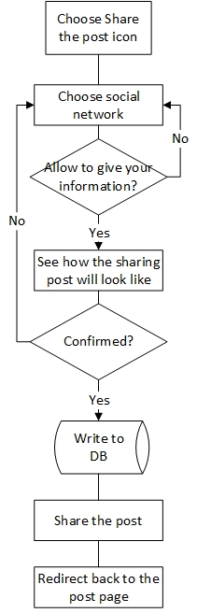

1. [**Questionnaire**](https://slovari.yandex.ru/questioning/en-ru)

User could fill the test and see result. Example: Is your home clean enough? Are you waste full? And depending of the result user get the advise which articles to read.

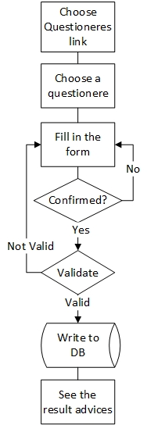

1. **User Cabinet**

Enables users to change their profile photo, name, email or phone. Gives the opportunity to review and change their profiles.

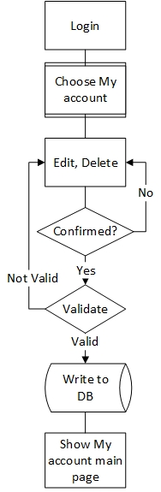

1. **Promotions pages**

Enable users to see list of promotions and buy one with paypal.

